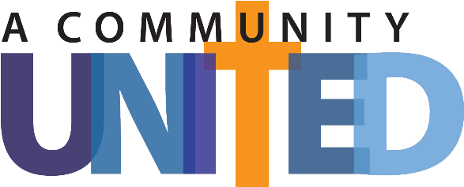
Social Media posts

Facebook Post 1 (Leading up to Commitment Weekend):
🙏🏼🌟 Save the Date! Commitment Weekend: A Community United! 🌟🙏🏼
Dear Catholic Community, mark your calendars for Commitment Weekend on [Date]. It's a time when we, as a community united in faith, service, stewardship, and mission, come together to reflect on our blessings and commit to living as faithful stewards of God's gifts. Join us as we explore ways to grow together, support one another, and make a difference in our parish community and the world. Stay tuned for more details! 🙌🏼❤️
📢 Call to Action: Share in the comments one thing you appreciate most about our parish and how you plan to contribute to our shared commitment efforts. Let's inspire one another! 💬
#CommitmentWeekend #CommunityUnited #FaithfulStewards #ServeWithLove #MissionDriven

Facebook Post 2 (Leading up to Commitment Weekend):
⭐️💖 Our Church Needs You! A Community United in Commitment! 💖⭐️
Dear Catholic Community, as Commitment Weekend approaches, let us remember the importance of giving. Our parish relies on the generosity of our members, a community united in faith, service, stewardship, and mission, to support our ministries, programs, and outreach efforts. Your financial contributions make a tangible difference in the lives of others. Please prayerfully consider increasing your giving and joining us again in being faithful stewards of God's blessings. Together, we can make an impact and share His love with all. 🙏🏼❤️

📢 Call to Action: Please let us know in the comments the actions each of us can take to foster a sense of unity in our parish community. Your ideas can inspire others! 💬💝
#GiveGenerously #MakeAnImpact #CommitmentWeekend #CommunityUnited #FaithCommunity

Facebook Post 3 (Leading up to Commitment Weekend):
🌍✨ We Are Called to Mission: A Community United! ✨🌍
Dear Catholic Community, we invite you to embrace the mission of our parish community. As followers of Christ, we, a community united in faith, service, stewardship, and mission, are called to bring His light to the world, to be agents of love, compassion, and justice. Commitment Weekend is an opportunity for us to renew our commitment to mission-driven living, to reflect on how we can use our time, talents, and resources to make a positive difference. Join us in making our community and the world a better place through our actions. 🌟🙌🏼
📢 Call to Action: Share in the comments one way you plan to live out your mission as part of our parish community. Let's encourage each other and create a ripple effect of positive change! 💬✨
#MissionDrivenLiving #SpreadLove #MakeADifference #CommitmentWeekend #CommunityUnited

Facebook Post (Thank You, after Commitment Weekend):
🙏🌟 Grateful for Your Generosity: A Community United! 🌟🙏
Dear Catholic Community, we extend our heartfelt gratitude for your generous support during Commitment Weekend. Your commitment to faith, service, stewardship, and mission, as a united community, is truly inspiring. With your contributions, we can continue to nurture our parish community, reach out to those in need, and spread the love of God. Thank you for being faithful stewards and partners in our mission. Together, as a community united in purpose and love, we are making a difference! 🙌🏼❤️
📢 Call to Action: Please share in comments one positive experience or impact you've witnessed through your giving or involvement with our parish. Let's celebrate the power of our collective efforts and the blessings we've experienced as a united community! 💬🌟
#GratitudePost #ThankYou #CommunityUnited #FaithfulStewards #CommitmentWeekend

