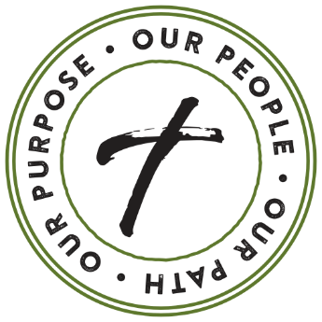
Our Path Forward – 2021 & Beyond
Weekend 1 – Announcement Weekend
Sample Script

The far-reaching impact of Covid-19 has changed us in many unexpected ways - from devastating losses of loved ones, isolation, fear of the unknown, disruptions in day-to-day activities and more. Please know I pray for you all. For those who continue to struggle or may just need a little extra support and encouragement, if there is anything our community can do to help, please reach out. Our Catholic faith joins us together, and with this, we will move forward, beyond the challenging, solemn days of the global pandemic.

Our Path Forward – 2021 & Beyond is the fitting theme we will focus on as we discuss stewardship this year. If we have learned anything at all from the past year and a half it is that, we must be prepared for the unknown. We must prepare our parish not just for this year, or for next year, but be sure we are positioned to thrive well into the future. So, I will be speaking not just about supporting our parish through your offertory contributions, but also contributing to our established endowment, which supports our parish in perpetuity – eternally.

I’d first, and most importantly, like to say Thank You!

- Thank you for being a part of our parish, our community, our family

- Thank you for joining us every weekend in prayer and worship – even online as we’ve not been able to meet in person. Did you know, more than XXXX households on average watch our livestream Masses?

- Thank you for participating in ministry and outreach – we are blessed with some of the most generous and hardworking volunteers

- Thank you for providing the necessary resources to make all this happen.

- (if you feel comfortable doing so insert a joke…Thank you for sitting through my long homilies)

While we begin to return to a new sense of normalcy, there was a time I had to face the reality that many of our programs, ministries, and ability to evangelize, minister, and fully function as a thriving faith community were at risk. But, we rallied together and have stabilized our offertory, in turn stabilizing our ministry. We are on our path forward.

Because of your generosity, contributions of time and of your varying talents, we continued to provide vital services to those in need during challenging times. We came together as a community in worship and we supported each other in countless ways.
Your gratitude, generosity and love for others is prevalent in everything we do as a parish family. I see the good God’s people do when we work together. I pray we can continue to do God’s work, and to do his work more abundantly.

There are many ways you may financially support our parish. You might choose to make a gift to weekly offertory or to our established endowment fund that earns interest each year and will continue to support our parish far into the future. Or, you may consider adding our parish as a beneficiary in your will.

Your support of our parish is a real way to effect change, to give back, to help someone you may never meet or know, to support our valuable ministries, and to say “thank you” to the Lord for his many blessings. I am not asking you to make this decision now, but to take some time over the next week to prayerfully consider what your level of financial support will be over the coming year and to be prepared to make your commitment next weekend.

You may log onto www.opfaob.com to support our offertory and to contribute to our established endowment fund.

Thank you in advance for giving our ministries the resources to transform lives at our church and in our local community.

