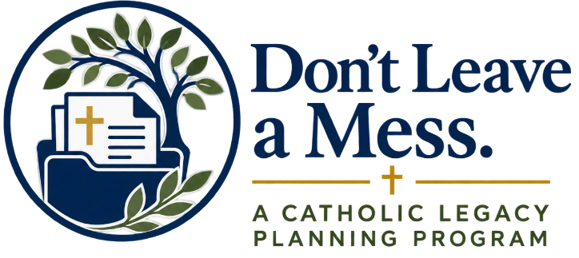

Week 2 Homily

Last week, we began by reflecting on some of the things that matter most in our lives: the people God has entrusted to our care, the values we hope to pass on, the role our faith has played in our lives, and the legacy we hope to leave behind.
This week, we take the next step.
We move from reflecting on those things to putting some of them in writing.
There is a very practical side to Christian stewardship that we do not always talk about. We are accustomed to thinking about stewardship in terms of our time, our talents, and our financial giving. But stewardship is also about taking responsible care of what God has entrusted to us and making thoughtful preparations for the people we love.
Jesus speaks about the faithful and prudent steward. That image is one of responsibility. A good steward pays attention to what has been entrusted to him. He prepares. He acts with care. He does not simply leave important things for someone else to figure out later.
That same spirit can guide us in some very ordinary parts of our lives.
Most of us know there are things we probably should have in order.
Do I have a will? If I already have one, when was the last time I looked at it?
If I were unable to handle my financial affairs, have I decided whom I would trust to help?
Does my family know what I would want if I faced a serious medical situation?
Are the beneficiaries on my retirement accounts, insurance policies, and other accounts still the people I intend them to be?
Would someone know my medications and important medical information in an emergency?
Does my family know my wishes for a Catholic funeral?
These are not necessarily things we enjoy thinking about. They are very easy to put off.
But preparing them can be an act of care.
This week, through Don’t Leave a Mess, the Archdiocese of Baltimore is providing a collection of resources to help us begin.
A good place for many people to start is with a will.
A will helps make your wishes clear, provides direction for the people who will one day settle your affairs, and allows you to provide for the people and causes that matter to you. Through the Archdiocese, My Catholic Will is available at no cost. It is an online tool designed to guide you through the process of creating a will while also allowing you to think about your faith and the legacy you hope to leave.
Another important subject to understand is Financial Power of Attorney.
A Financial Power of Attorney can allow you to name someone you trust to handle financial or legal matters for you if you are unable to handle them yourself. It can be an important part of a good estate plan, but it can also give another person significant authority.
For that reason, Don’t Leave a Mess does not provide a Financial Power of Attorney form for you to simply download and sign. Instead, the website explains what the document is, why it may be important, and some of the questions you should consider. If you need one, that is a conversation to have with a qualified estate-planning attorney who can help make sure the document is appropriate for your circumstances and that you understand the authority you are giving to another person.
We also have a Beneficiary Planning Worksheet.
This is important because your will does not necessarily control everything you own. Retirement accounts, life insurance policies, annuities, and certain bank and investment accounts may pass directly to the beneficiaries named on those accounts.
The worksheet helps you think about whom you want to provide for, identify accounts that may have beneficiaries, review who is currently named, and determine whether anything needs to be updated. It does not make those changes for you, but it can help you identify what needs your attention.
There are also important decisions involving healthcare.
The Catholic Medical Advance Directive allows you to put your healthcare wishes in writing and name someone you trust to make healthcare decisions for you if you become unable to make or communicate those decisions yourself.
The website includes a guide to help you understand those decisions, along with the Catholic Declaration for Health Care Decision Making provided by the Maryland Catholic Conference. It gives us a way to approach difficult medical decisions while respecting the dignity of human life and the teachings of our Catholic faith.
Along with that is a HIPAA Authorization. This can allow trusted people to receive medical information when needed. It is one more way of making sure that the people who may need to help us are able to get the information they need.
There is also an Emergency Medical Information resource.
This gives you a place to keep important medical information together and easily available in an emergency. Something as simple as having your medications, medical conditions, physicians, allergies, and emergency contacts organized can be a tremendous help when a family member suddenly has to accompany you to a hospital or help with your care.
And finally, there is Catholic Funeral Planning.
Our Catholic funeral rites are an important expression of our faith. They are the prayer of the Church for the person who has died and a proclamation of our hope in the Resurrection.
The website provides both a Catholic Funeral Planning Guide and a worksheet. You do not need to plan every detail of your funeral. The purpose is to think through the decisions that matter most, write down your wishes, and make sure the people you love know where to find them.
Now, hearing all of that at once may sound like a lot.
A will. Financial Power of Attorney. Beneficiaries. Medical decisions. HIPAA authorization. Emergency information. Funeral planning.
No one is suggesting that you go home this afternoon and complete everything.
For some people, much of this may already be done. If so, this may simply be an opportunity to look at what you have and ask whether it is still current.
For others, there may be several things that have never been addressed.
The important thing is simply to begin.
Ask yourself three questions:
What do I already have?
What is missing?
What needs to be updated?
Then choose one place to start.
And as we put these things in order, there is another question worth considering as people of faith.
After we have appropriately cared for our families and those who depend upon us, what do we want the blessings God has given us to continue accomplishing?
For many of us, our parish has been present at some of the most important moments of our lives. It is where we have worshiped, received the sacraments, raised children in the faith, celebrated marriages, mourned those we love, and encountered Christ through a community of faith.
There may also be Catholic schools, ministries, charities, or other works of the Church that have been important to us.
As you review your will and your beneficiary designations, it is worth prayerfully considering whether your parish or another Catholic ministry should be part of the legacy you leave behind.
It does not have to be complicated. It is simply another question to consider: if my faith has helped shape the way I have lived, how might it also be reflected in what I leave behind?
So the invitation for this week is practical.
Go to DontLeaveAMess.org and choose “Document.”
Look through the resources.
Do not feel that you need to do everything at once. Find the one or two areas that need your attention most and begin there.
And perhaps that is one of the quieter ways we can love the people God has placed in our lives: by preparing carefully, by making our wishes clear, and by not leaving difficult decisions unnecessarily for someone else to make.
May the Lord give us the wisdom to be good stewards of all that He has entrusted to us, the courage to make the preparations we may have been postponing, and the grace to leave behind a legacy rooted in faith, generosity, and love.
Amen.

