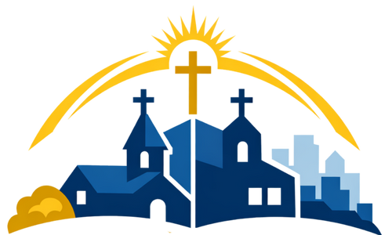

Sister Parish Partnership - Pulpit Announcement
Our parish is beginning to explore the Sister Parish Program, an initiative of the Archdiocese of Baltimore that brings parishes together across city, suburban, and rural communities to build relationships rooted in faith and shared mission.
This program is about walking together as one Church. Sister Parish partnerships can include shared prayer, joint service projects, youth and ministry collaboration, parish visits, cultural celebrations, and other opportunities to learn from and support one another.
These relationships grow through parishioners who are willing to help lead and support the partnership. With the support of our pastor and the Archdiocese, parishioners help organize communication, coordinate activities, and nurture the relationship over time.
We are especially looking for parishioners who feel drawn to leadership in this area—those who enjoy building relationships, organizing efforts, or helping connect people around a shared mission.
If this is something you would like to learn more about, or if you feel called to help lead or support this effort, please contact the parish office. We would love to talk with you and share more about what this could look like for our parish.
Please keep this in prayer as we discern how we might live out this shared mission together.

