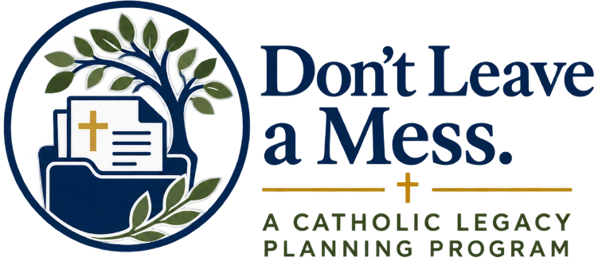

Week 3 Homily

Over the past few weeks, we have been reflecting together on something we have called “Don’t Leave a Mess.” The title is simple, but the concern behind it is deeply Christian. It is about the responsibility we have to care for the people God has entrusted to us, not only in the present moment, but also by preparing thoughtfully for the future.
In the first week, we reflected on what matters most to us: our families, our faith, the things God has entrusted to our care, the way we would want important decisions to be made, and the legacy we hope to leave.
Last week, we considered the practical tools that can help us put those intentions into writing: a will, medical directives, funeral plans, important information for our families, beneficiary designations, and other documents that can help bring order and clarity to our wishes.
This week, there is one more important step.
We need to share.
A good plan is not complete if no one knows that it exists.
There is a beautiful moment in the Gospel of John that can help us think about this. As Jesus hangs upon the Cross, He sees His mother and the disciple whom He loves standing nearby. He says to His mother, “Woman, behold, your son,” and then to the disciple, “Behold, your mother.” Saint John tells us that from that hour the disciple took Mary into his home.
Even in the midst of His suffering, Jesus is attentive to the care of another person. He does not simply have a concern in His heart. He communicates it. He entrusts Mary to someone, and He makes that responsibility known.
There is something important for us in that example.
Love does not simply mean caring about someone. Love also means doing what we can to make things clearer and easier for the people who may someday have to act on our behalf.
That is why sharing our plans matters.
If someone may someday be responsible for making healthcare decisions for us, that person should know. More importantly, we should talk with that person about what matters to us, what we would want, and how our Catholic faith shapes the way we understand medical care and the dignity of human life.
If we have prepared a will, someone we trust should know that it exists and where it can be found.
If we have organized important financial, insurance, account, or contact information, our family should know where that information is kept.
If we have made plans for a Catholic funeral and burial, the people closest to us should understand those wishes and why they matter to us.
And if we have chosen someone to serve in an important legal or financial role, that person should know that responsibility has been entrusted to them.
These conversations may not always be easy to begin. Most of us do not naturally sit around the dinner table talking about medical decisions, wills, funerals, or what should happen when we are no longer able to speak for ourselves.
But having these conversations can be a genuine act of charity.
When a family is facing serious illness, incapacity, or the death of someone they love, there is already much to carry. That is not the moment we want our family members asking, “What did Mom want?” or “Where did Dad keep that?” or “Who are we supposed to call?”
Sharing our wishes now can remove some of that uncertainty later.
It can give the people we love direction when they need it most.
And these conversations give us an opportunity to share something even more important than documents.
They give us an opportunity to share our faith.
We can tell our children why receiving the sacraments during serious illness matters to us.
We can explain why we want a Catholic funeral and why the prayers of the Church are important.
We can tell our family why we have chosen to support our parish, a Catholic ministry, or another charitable cause through our estate or beneficiary plans.
We can speak about the values and traditions we hope will continue after us.
Because ultimately, our legacy is much more than the possessions we leave behind.
Our legacy is also the faith we practiced, the people we loved, the generosity we showed, the lessons we taught, and the example we leave for those who come after us.
So this week, the invitation is very simple.
Share.
Choose the people who need to know your wishes and begin the conversation.
Tell them what you have prepared.
Tell them where important information can be found.
Talk about the responsibilities you may be asking them to accept.
And most importantly, tell them why these things matter to you.
Over these three weeks, we have followed a simple progression.
First, reflect. Prayerfully consider what matters most, how you want to care for the people you love, how your faith should guide important decisions, and what kind of legacy you hope to leave.
Then, document. Put those intentions into writing and make use of the resources available to bring order to the important parts of your life.
And finally, share. Make sure the people who may someday need this information know your wishes, understand your intentions, and know where to find what you have prepared.
Christian stewardship is ultimately about recognizing that everything we have has first been entrusted to us by God.
Our families. Our possessions. Our resources. Our faith. Even the time that we have been given.
Caring well for those gifts includes preparing for the day when others may have to carry responsibilities that once belonged to us.
So let us not leave them guessing.
Let us give the people we love the gift of clarity.
Let us share our wishes, our plans, and our faith.
And may the Lord give us the wisdom to prepare well, the courage to have these conversations, and the grace to leave behind a legacy rooted in faith, love, and faithful stewardship.
Amen.

