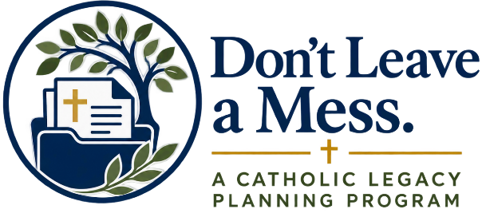

Dear Parishioners,
This weekend, we began a new parish initiative called Don’t Leave a Mess—an opportunity to think prayerfully and practically about how we care for the people and blessings God has entrusted to us.
Whether you were able to join us for Mass this weekend or not, I encourage you to take some time this week to reflect on a simple but important question:
What do I want my legacy to be?
Our Catholic faith reminds us that everything we have—our life, our family, our faith, our possessions, and our resources—is ultimately a gift from God. Being a good steward of those gifts includes thinking about what we hope will happen when others may someday need to make decisions on our behalf or care for the things we leave behind.
This week, consider some of these questions:
- Who are the people God has entrusted to my care?
- If I could not speak for myself, what would I want others to understand about my medical care and my Catholic faith?
- How would I want my funeral and burial to reflect my belief in Christ and the resurrection?
- What possessions, resources, responsibilities, and important information have been entrusted to me?
- What do I hope my children, grandchildren, family, and friends remember about the way I lived?
- How do I want my faith, generosity, and care for others to continue through the legacy I leave?
You do not need to answer every question this week. The first step is simply to reflect. Take some quiet time, bring these questions to prayer, and ask God to help you recognize what matters most.
We have also prepared a Week One Reflection Guide to help you think through these questions more deeply.
You can find the Reflection Guide and additional resources at:
DontLeaveAMess.org
Next week, we will begin looking at practical tools that can help us put these thoughts and wishes in order.
Please join me in asking God for the wisdom to be faithful stewards of all He has given us and to leave behind a legacy of faith, love, generosity, and care.
God bless,
Father [Name]

