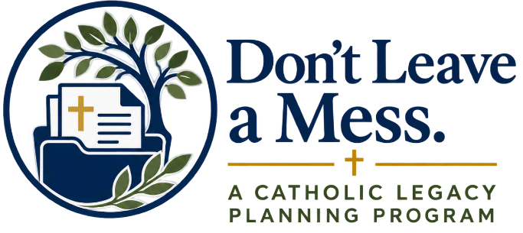

Week 2 email
Dear Parishioners,
This week, as part of our Don’t Leave a Mess series, we are focusing on something very practical: putting our plans in order.
Last week, we reflected on the people, values, faith, and priorities that matter most to us. This week, the invitation is to begin turning those reflections into action.
For many of us, there are documents we know we should have but have never completed, or documents we created years ago and have not reviewed since. To help with that, a number of resources are now available, including:
- My Catholic Will
- Financial Power of Attorney (Advice and Guidance)
- Catholic Medical Advance Directive
- HIPAA Authorization
- Emergency Medical Information & Contacts
- Catholic Funeral Planning Worksheet
- My Important Information Organizer
- Beneficiary Planning Worksheet
Each resource includes guidance to help you understand what it is, why it matters, and how to begin.
This kind of planning is an important act of stewardship and care for the people we love. It can help our families understand our wishes, locate important information, and make decisions with greater clarity when necessary.
It is also an opportunity to think about the legacy of our faith. After providing appropriately for family and loved ones, I encourage you to prayerfully consider remembering our parish first, as well as Catholic ministries that have been important in your life. This can be done through a gift in your will or estate plan, or by naming the parish or another Catholic ministry as a beneficiary.
You do not need to complete everything at once. Begin by asking a few simple questions: What do I already have? What is missing? What needs to be updated?
Visit dontleaveamess.org to explore the resources, learn more about each document, and begin working through the ones that are right for you.
Taking the time to put these matters in order is one more way we can care for those God has entrusted to us and be faithful stewards of the blessings we have received.
God bless,
Father [Name]

